PROJECT REPORT

ON

Scrolling display using neopixel LED matrix

SUBMITTED BY

Omkar Kashid

Madhuri Mahale

Shilpa Sanap

Under the Guidance of

Mr.Ramgopal Sahu





DEPARTMENT OF ELECTRONICS & TELECOMMUNICATION

P.E.S’S MODERN COLLEGE OF ENGINEERING

PUNE – 411 005.



SAVITRIBAI PHULE PUNE UNIVERSITY

Academic Year: 2021-22

CERTIFICATE

This is to certify that

**Omkar Kashid Exam No.**

**Madhuri Mahale Exam No.**

**Shilpa Sanap Exam No.**

Of T.E. E&TC have successfully completed the Project titled ‘**Scrolling display using** **neopixel LED matrix**’during the academic year 2021-22 for the Course **Emplyability Skills and Mini Project**. This report is submitted as per the requirement prescribed by Savitribai Phule Pune University.

**Dr. Mrs. R. S. Kamathe Mr.Ramgopal Sahu**

**H.O.D. (E&TC) Project Guide**

ACKNOWLEDGEMENT

In performing our project , we had to take the help and guideline of some respected persons, who deserve our greatest gratitude.The completion of this project gives us much Pleasure. We could like to show our gratitude towards Mr.Sahu Sir for giving us guideline for project throughout numerous consultations. We would would also like to expand our deepest and indirectly guided us in writing this project.

In addition ,a thank you to our industry experts who introduced us to the Methodology of work , and whose passion for the “underlying sturctures” had lasting effect.

Many people, especially our classmates and team members itself ,have made valuable comment suggestions on this project which gave us an inspiration to improve our project. We thank all the people for their help directly and indirectly to complete our project.

**LETTER FROM THE SPONSERER (if any)**

**[On Sponserer’s** letter-head]

Compulsory for all the sponsored projects on Company’s letter head

**ABSTRACT**

The led Display System is aimed at the colleges and universities for displaying day-to-day information continuously or at regular intervals during the working hours. It offers flexibility to display flash news or announcements f. -based display system can also be used at other public places like schools, hospitals, railway stations, gardens etc. without affecting the surrounding environment. The led display system mainly consists of a receiver and a display toolkit which can be programmed from an Arduino IDE platform. It receives the message, through serial port and displays the desired information after necessary code conversion. It can serve as an electronic notice board and display the important notices instantaneously thus avoiding the latency. Being modular design, the led display is easy to expand and allows the user to add more display units at any time and at any location in the campus depending on the requirement of the institute

**TABLE OF CONTENTS**

(Size 16Times New Roman, bold)

Sr. Page No.

1. Introduction 1

2. Literature Survey

3. System Specifications

4. Block diagram & description

5. Hardware System Design

5.1

5.2 XXXXXX { Detailed Design of each block}

5.2.1

5.2.2

6. Software System Design

(Algorithms & Flowchart)

7. Enclosure design and description

8. Results and Discussion

9. Bill of Material

10. Applications & Future modifications

11. References

12. Data Sheets. (Only for Major components)

1. **Introduction**

Display advertising plays a very importing role in marketing and there are several advertisement methods like newspapers, posters, glow signboards, etc. but digital LED display boards are getting popular nowadays because of their reliability and advantages.

Although they are a little bit expensive still, they are durable and customizable, like the advertising text can be changed easily whenever needed and they can also be usedas Digital Notice Board at any public place .This project includes LED strip of 300 led to control the text displayed over it and Scrolling LED display is implemented by using AVR microcontroller.

1. **Literature Survey**
   * Survey of similar products already available in the market ( Specifications not needed)
   * Comparison with various other technologies available to implement the same.
   * Reference from journal paper(Any one paper from IEEE) is essential

(Not more than 2-3 pages)

1. **Specifications**

(Electrical &Mechanical)

1. **Block diagram & description**

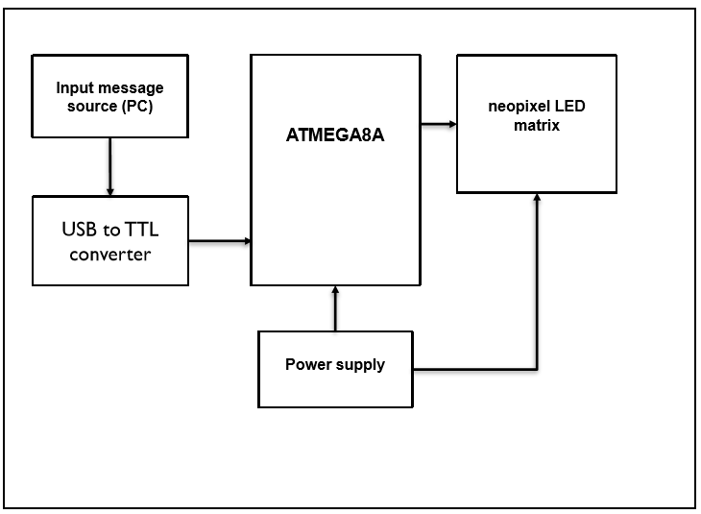

After turn ON the power supply fix message get scrolling on the Led matrix display.

▪ Take the text message from PC into input buffer of microcontroller through USB to TTLconverter.

▪ Microcontroller Convert this text message into Led matrix display format. ▪ After conversion of text message into matrix format, Display it on LED matrix.

▪ Fix image can be display or animated which is stored into microcontroller memory.

▪ We can program each led separately with the help of fast led library we can create different animations and characters.

▪ After uploading code to Atmega Microcontroller should use a 6.0-ampere power supply. Because at maximum brightness a neopixel led draws around 20 mA current. We have total 300 LEDs so 300*20=6.0A.

1. **Hardware System Design**
   * 5.1 Detail design of each block
   * 5.2 Hardware design should be followed by complete circuit. Diagram. Specifying component nos. & type. (This should match with the component list) circuit. Diagram should be on double A4 size paper.
2. **Software System Design** :
   * Each flow-chart & algorithm should be property titled & indexed (ex. 6.1, 6.2, etc, - same should appear in table contents) indicating the function that flow-chart is doing w.r.t. the project.
3. **Enclosure**

design and description should consist of Mechanical design (cabinet design (Material used, dimensions), front panel etc.)

1. **Result and Disscussion**

(Snap shot of output with explainations /results in the form of graph/tables with explaination /simulation results with explaination )

1. **Bill of Material :**

|  |  |  |  |  |
| --- | --- | --- | --- | --- |
| **Sr.No** | **Component name , Model Name and Specification** | **Quantity** | **Rate/ Item (Rs.)** | **Total Cost(Rs.)** |
| 1 | Transistor, BC 547, NPN Transistor | 2 | 5/- | 10/- |
| 2 |  |  |  |  |
| 3 |  |  |  |  |
| 4 |  |  |  |  |
| 5 |  |  |  |  |
| 6 |  |  |  |  |
| 7 |  |  |  |  |
| 8 |  |  |  |  |
|  |  |  | **Total Amount (Rs.)** |  |

1. **Applications& Future modifications :**

A. Educational Institution and Organization: Currently we rely on putting up papers on notice boards to inform people of events. This method can be discarded by using GSM based LED display to display information in real time. E.g. Placement news, cultural activities news, etc.

B. Advertisement: In shopping malls we get to hear the offers on various products from time to time. Instead we continuously display the information regarding the products and related offers on electronic display boards.

C. Railway Station: Instead of announcing the delay in arrival of trains we can display the information.

D. Hotels: To display the availability of the rooms and the room rents the type of rooms.

E. Nursing homes: To display the staff attendance, the availability of the doctors, the list of the specialized doctors, no of in patients etc.

1. **Conclusion :**

Scrolling LED display is yet another simple device which can be used to display information or notice for various applications. Microcontroller with niopixel led matrix can perform various scrolling pattern which are attractive as well as informative. Thus, this project is very suitable for small scale as well as medium scale information display. This model can be used very efficiently in establishments like chain restaurants wherein the order and special discounts can be displayed at all branches simultaneously, in colleges wherein students and staffs can be informed simultaneously in no time. It can be set up at public transport places like railways, bus station, and airport and also at roadside for traffic control and in emergency situations, it is cost efficient system and very easy to handle. Latency involved in using of papers in displaying of notices is avoided and the information can be updated by the authorized persons.

1. **References :**

[1] Jeena Joy, Athira Poovathody, Athul R S, Athul Subran, Basil Paul, Implementation of Digital Dice Game‖, Professor, Dept. of EEE, Mar Athanasius College of Engineering, Kothamangalam1 UG Student, Dept. Of EEE, Mar Athanasius College of Engineering, Kothamangalam, India2, 3, 4, 5, Vol. 3, Issue 2, February 2014.

[2] Harold Thimbleby FIT Lab Interaction Laboratory, Swansea University, Don’t use seven segment displays‖ Swansea, Wales. p- 1-6

[3] Pang, GKH; Chan, CH; Kwan, TTO, Tricolor lightemitting diode dot matrix display system with audio output‖, IEEE TRANSACTIONS ON INDUSTRY APPLICATIONS, VOL. 37, NO. 2, MARCH/APRIL 2001 , p.534-540.

[4] Ervin John U. Benigra, Bryan Leonard D. Montaño and Engr. Maridee B. Adiong,‖ RUNNING MESSAGE BOARD USING DOT-MATRIX DISPLAY‖ Capitol University ,College of Engineering, Cagayan de Oro City.

[5] Wojciech Kunikowski, Ernest Czerwiński, Paweł Olejnik, Jan Awrejcewicz, An Overview of ATmega AVR Microcontrollers used in Scientific Research and Industrial Applications, Department of Automation, Biomechanics and Mechatronics, Lodz University of Technology, 90–924 Łódź, 1/15 Stefanowski str. R. 19, Nr 1/2015, 15–20, DOI: 10.14313/PAR_215/15

1. **Data Sheets :**
   * (Only of special purpose devices )
   * [Typical project report Size : 50 pages excluding data sheets.]

**Except Title everything should be in size 12 Times New Roman**

**& sub Titles (If Any) Size 14 Times New Roman Bold**

**Seminar Report Should be Printed on A4 Size Executive Bond Paper &Spiral Bound.**

For any figures/graphs /block diagrams/photos/ tables add suitable caption i.e. Table No. 1/ Figure No. 1 etc.

Students may add photograph of their unit / setup.

GUI if prepared same should be printed and attached.

Do not include any code.

Do not include unnecessary figures or downloaded photos.

Size of report should be min: 35pages max: should not exceed 40-45 pages.

Contents should not be in ‘cut and paste’ from the reference paper and must be properly edited. Importance must be given to the report writing as it creates first impression on the external examiner.

**All T.E. Students (project groups) are hereby informed that alongwith project report, they should prepare a file having following contents:**

**1. All data sheets**

**2. Logbook (planning and actual workdone-weekly)**

**3. PPT in given Template**

**4. One Page Report**

**5. Mini project Poster**

Dr. Mrs. K.A.Adoni

Mr.Ramgopal Sahu

Mrs. Seema Bhalgaonkar